Zach Lyons

Information Exploration

Problem Set 3

**Monday**

1. This script takes any .png image and turns it into a text image.
   * 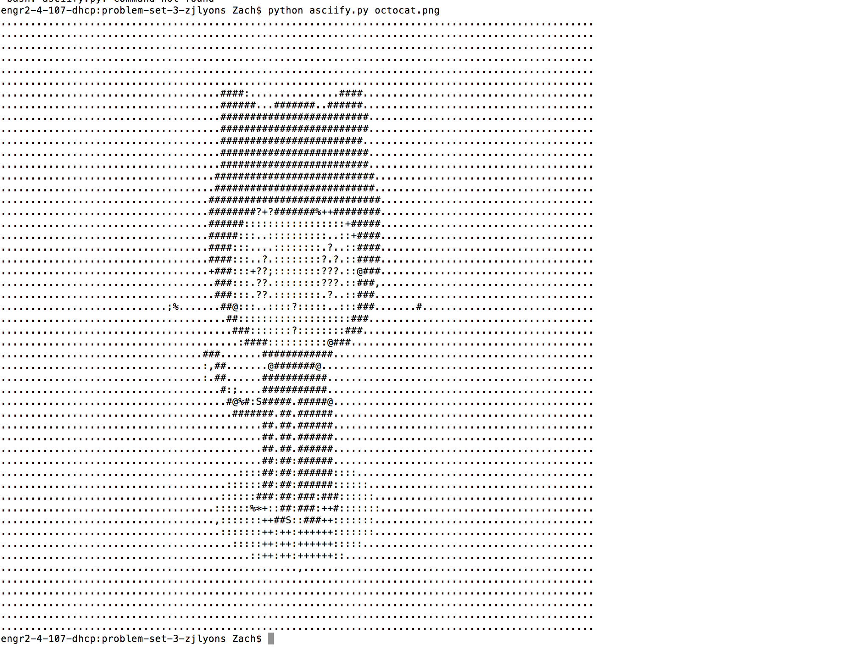
2. Used pip install delorean to install the package.

* Printed out this: Delorean(datetime=datetime.datetime(2018, 9, 10, 16, 48, 25, 978629), timezone='US/Eastern')